OOP Project 3 – “Four-ball” Billiard

Team members: 안정원, 유상일, 김지연, 임수연

Presentation speaker: 임수연

# Summary

In this project, we developed a simple simulation of a “four-ball” billiard game. The billiard table as the user sees it consists of a window containing a rectangle table with 2 red balls and 1 yellow and 1 white cue balls, imparting a certain amount of energy to it. On top of that, the program also shows the time remaining for each player to hit the ball and the direction of the cue ball in a green line. By pressing the space bar the screen is changed and the user can select on which part of the ball he/she would like to hit on. Also it shows the power gauge of how strong the user will hit the ball. Once a ball has energy it will start to move, reflecting off of walls, and potentially striking other balls. When a ball strikes another ball some of the energy of the first is given to the second, while the direction of movement of the two balls is changed by the collision. The user can go back to the previous screen by pressing any arrow keys and display the score by pressing onto the tab key. The program ends when ESC key is pressed.

# How to compile & execute

To compile and execute, use Visual Studio 2013. Open .sln file.

CAUTION: When running in a debugging mode, there may be some lags in the speed of the game while pressing onto any keys.

# Functionalities

## Changing of Camera

The camera view changes every time each actions are taken, for example, when the user presses the space bar to select the place and power of hitting the ball, the screen is changed into a more “convenient” view. Moreover, the camera follows the balls’ movement that is hit.

## Lights & Shadows

We added lights to the game for a more 3D looking view and also shadows to each objects.

## Spin of the Ball

The ball spins when it’s hit by the user. The user can see the ball spinning by observing the dots printed on the ball that’s hit.

## Curve of the Ball

The user can pick on which spot he/she would like to hit on the ball, and this causes the ball to curve when collided with another object. Further is explained in “Important Implementation Issues – Collision”.

## Strength of Hitting the Ball

The strength of hitting the ball can be determined by the user and the power gauge is displayed on the screen.

## Direction of the Ball

The direction of the ball is shown in a green line and the user can modify it using the arrow keys. The user can also press the shift key along with the arrow keys to increase the speed of changing the direction.

## Score Display

We also added a function to allow the user to see the current score by pressing onto the tab key.

# Important Implementation Issues

## Techniques behind 3D Objects

For us to represent 3D objects on a 2D space, we used WVP rule, which is composed of matrices: World matrix, View matrix, and Projection matrix. World matrix is a component that allows translation, rotation, scaling, etc. of any 3D objects. View matrix is another component that is mainly used for cameras. Lastly, projection matrix allows users to transform a 3D space into a 2D space for display.

## Lighting Implementation

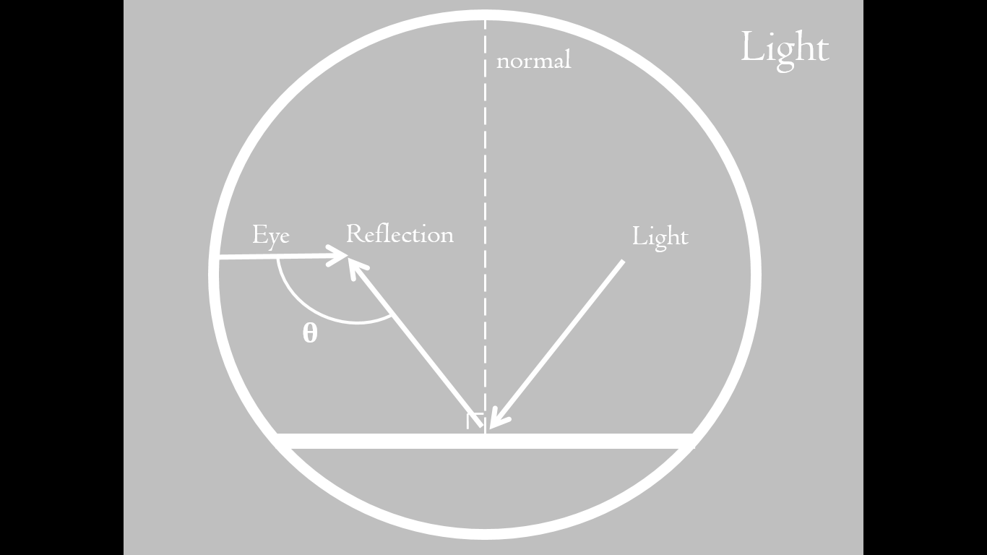

When a light is reflected on a smooth surface, the light is reflected in the same angle as the incident angle. Here, based on where the view—the place where the user is looking at—is located, we can get the angle between the reflected vector and the view vector. As this angle increases, the lighting is also increased, and vice versa. In other words, it becomes brighter. Using this concept, we implemented how the lighting is done on each objects according to different camera views.

## Spinning of the Ball

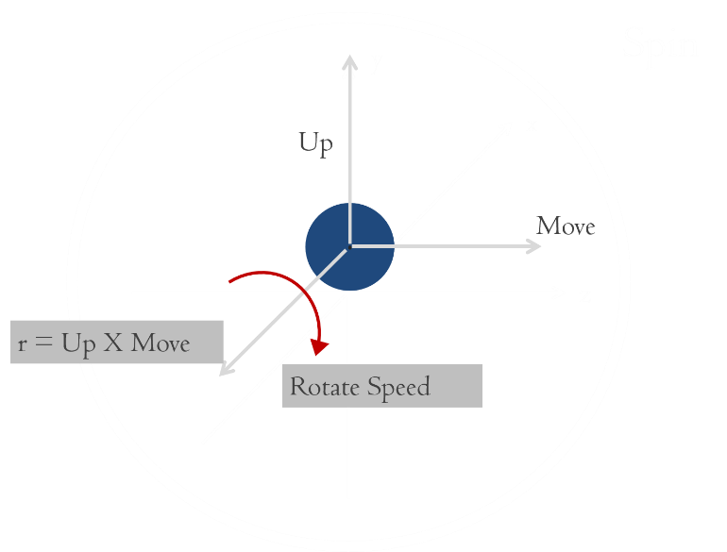

In the above picture, we can see that the ball has three components: up vector, move vector, and rotate vector. In order for us to get the rotation matrix, we used these three vectors and the function D3DXMatrixRotationAxis(), with the rotation vector and the value of rotation as the parameters. Now, using this rotation matrix, we applied it to the World matrix (explained in 4.1) which finally produces a proper display of a ball’s spin.

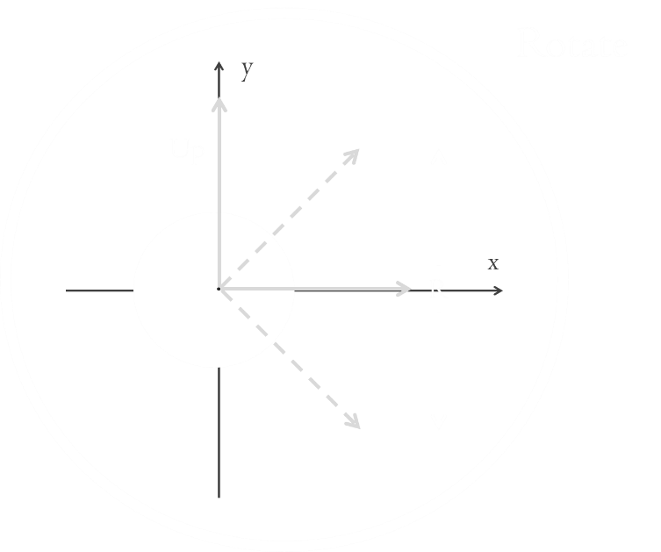

In this picture, u represents up vector and r represents rotation vector. Note that when the ball moves forward while spinning, the ball looks as if it is spinning in a diagonal direction. This is why as the rotating angle increases, the ball’s spinning direction is also tilted. In other words, as the absolute value of the amount of spin (spinning around the y-axis) increases, the rotating angle also increases. Therefore, when the ball stops but the amount of spin remains, the value of r becomes almost equal to the value of u.

## Camera Movements

In a 4x4 matrix, there exists an up-vector, front-vector, and right-vector. Using these vectors, we can change the point of view which becomes the View matrix. As shown in the above image, simply, the camera moves from its original place c1 to another place c2 from looking at a position p1 to position p2. In order for the camera to move smoothly, we used the exponential function.

## Collision

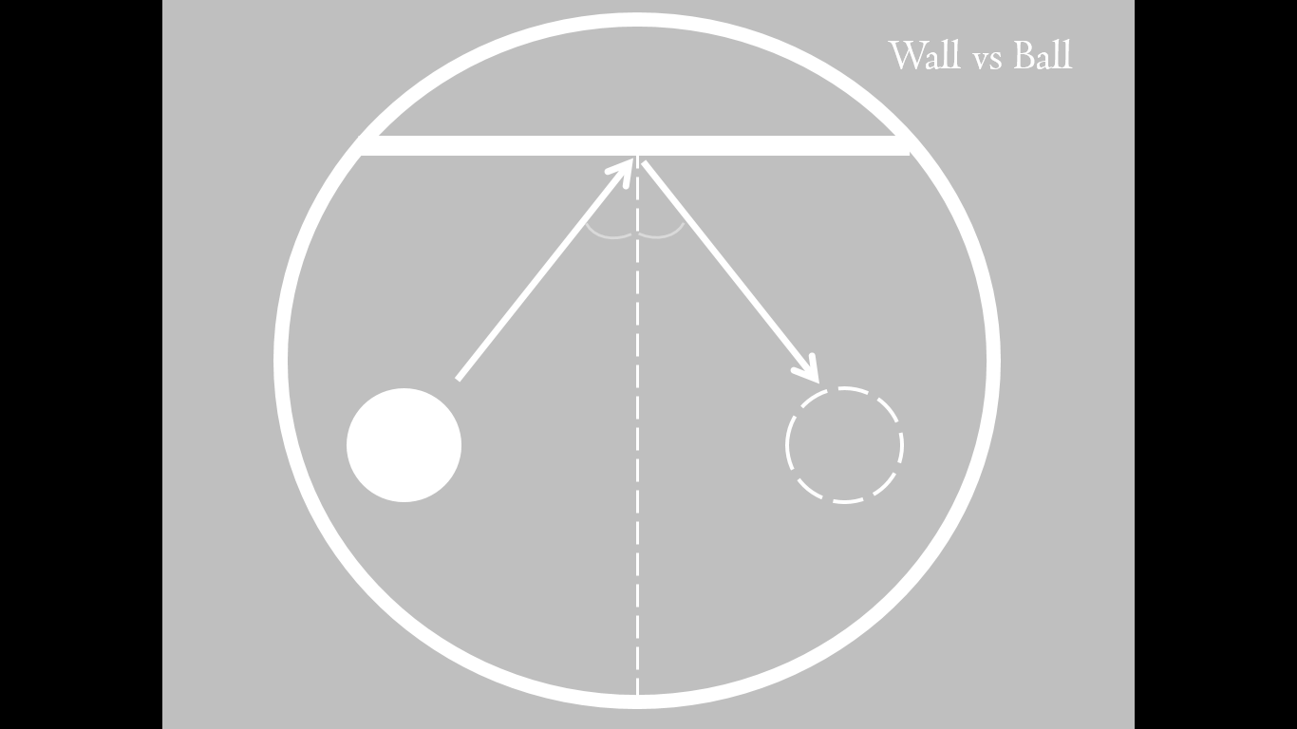 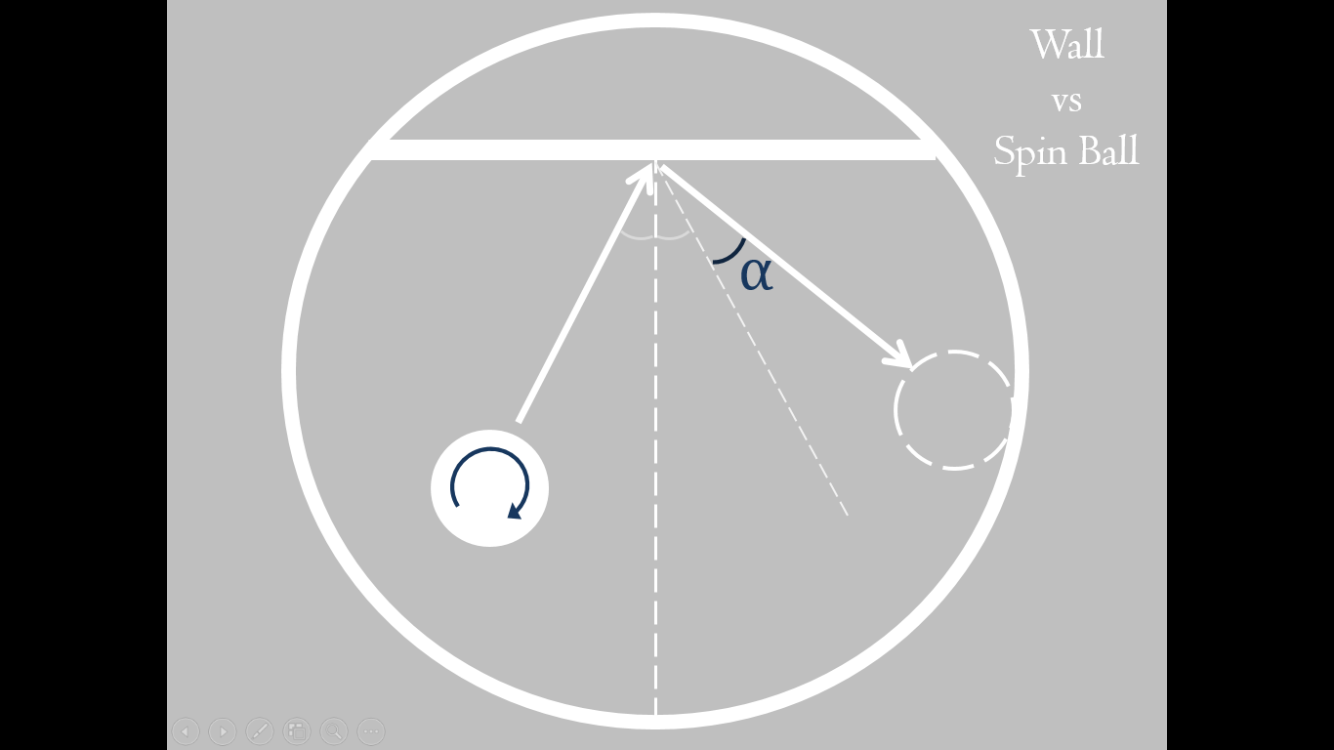 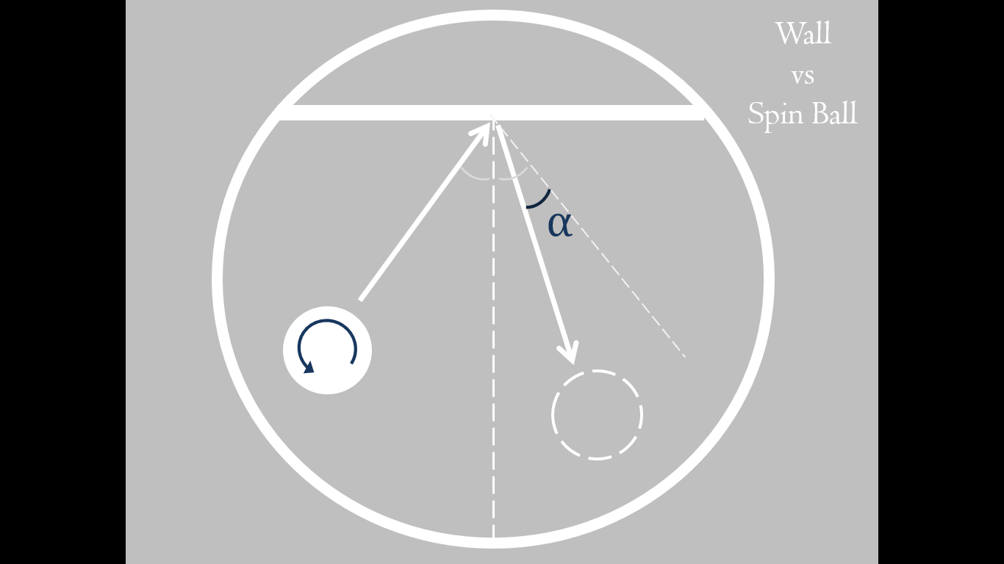

As we can see in the above three pictures, when a spinning ball hits an object, whether it is a wall or another ball, the reflected angle is slightly changed and the ball is curved into another direction. If the ball spins in a counter-clockwise direction, the reflected angle is decreased by α, whereas if the ball spins in a clockwise direction, the reflected angle is increased by α. In order to determine the spinning direction, the user can hit the ball on the left side and the right side for a clockwise direction and a counter-clockwise direction respectfully.

### Non-spinning Ball vs. Wall



When a ball without any spins (left or right spins) hits the wall, the ball is reflected off in a same angle as the incident angle. In order to determine the vector of the reflected ball, we used the function v’ = v + n * (n · v) * -2, where v represents the speed of the ball, and n represents normal vector. Note that before the ball is reflected off of the wall, it must be moved against the wall to increase smoothness.

### Spinning Ball vs. Wall

 

When there is a spin in a ball, based on the speed of rotation, the value of α changes. The important thing is, when the speed is too great, the angle α goes beyond the wall, which creates another reflection of the ball.

### Non-spinning Ball vs. Non-spinning Ball

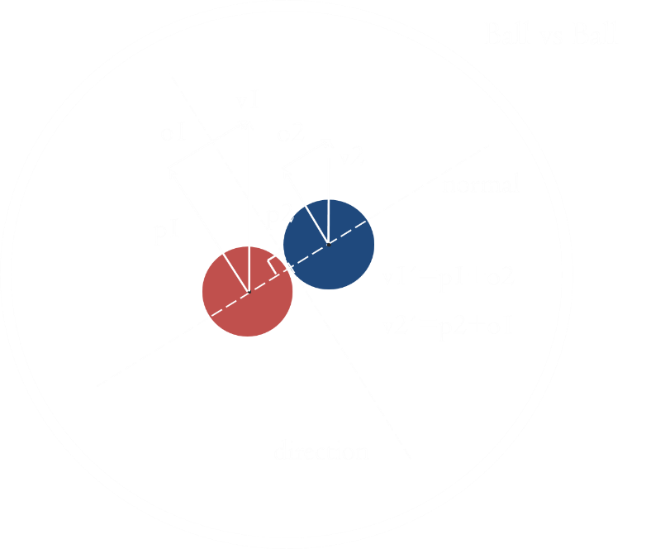

When two balls collide each other (both are not spinning), the direction of the balls are changed. As seen in the above image, in order to determine the new directions, we need a normal vector that crosses both balls through the middle. For this, it is necessary to move the balls to a place of collision. To find the position of the collision of two balls, we used the following method:

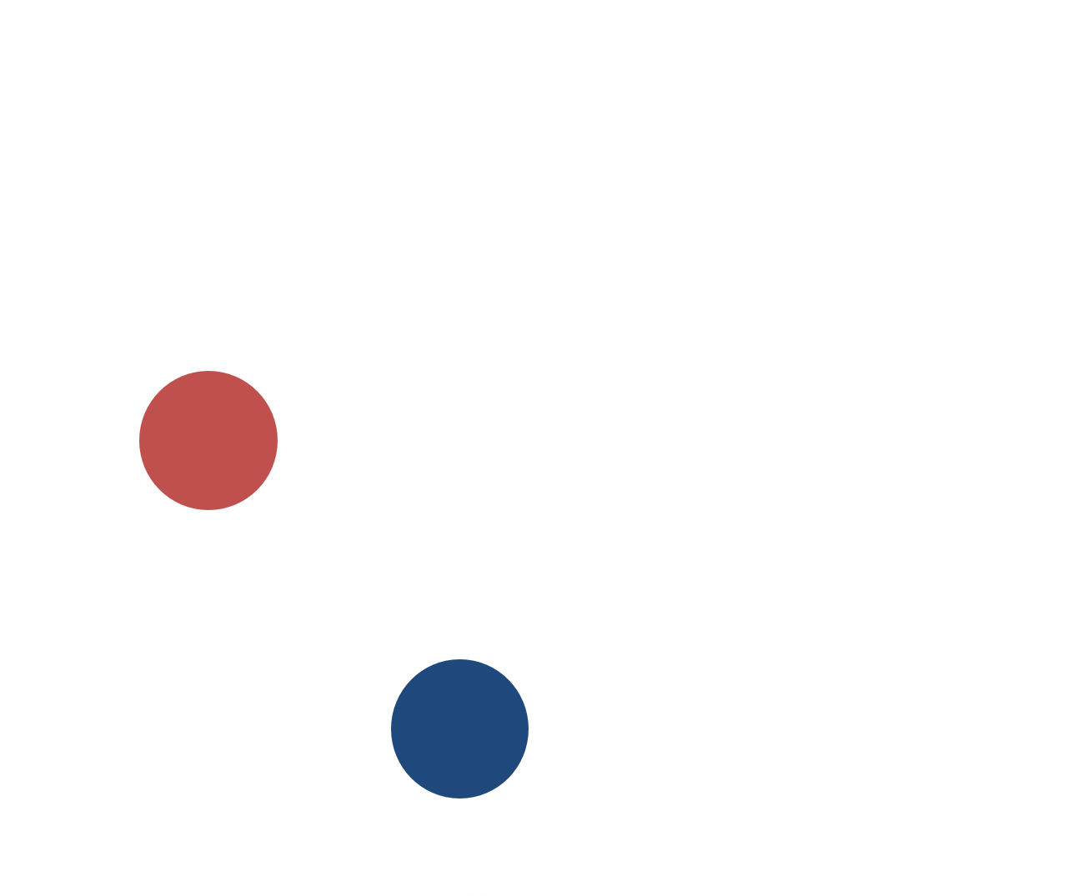

First, we created rectangles for each balls’ movements which is used to find out whether the balls actually collide by observing the intersection of the rectangles. Now we assume that there is a possibility of collision, then, we create lines for each balls’ movements and find the position of collision. This position’s delta represents the maximum position of a ball’s movement. With this maximum position, we use binary search to find the minimum length between the two balls right before the collision. Next, we move the balls to the position obtained and change the direction using the equations written inside the picture.

### Spinning Ball vs. Spinning Ball

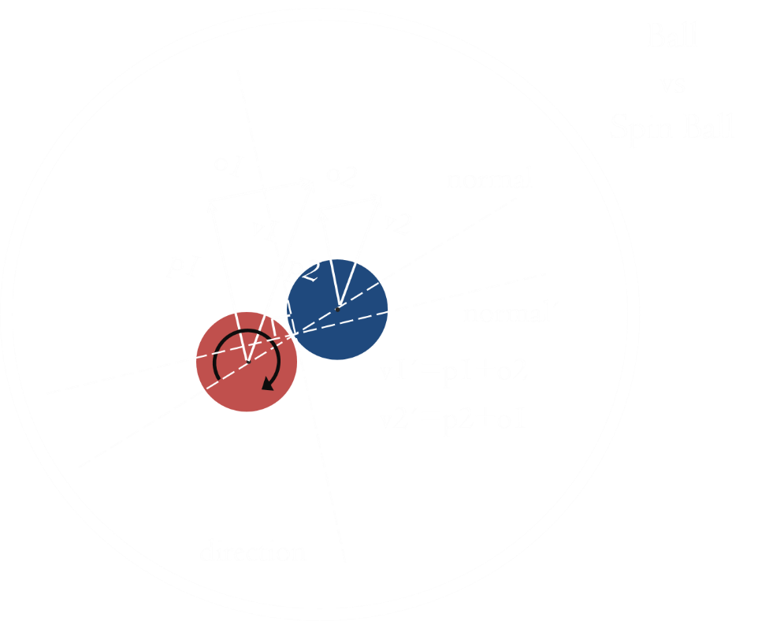

Collision between two spinning balls is simple. As explained in 4.5.3, we move the balls to the position right before the collision happens, and using the same equations, based on the direction of the rotation of the balls and with this value added to the equation, we tilt the normal vector. After tilting the normal vector, applying the same equation, we get the new directions.

# Result of SW system design

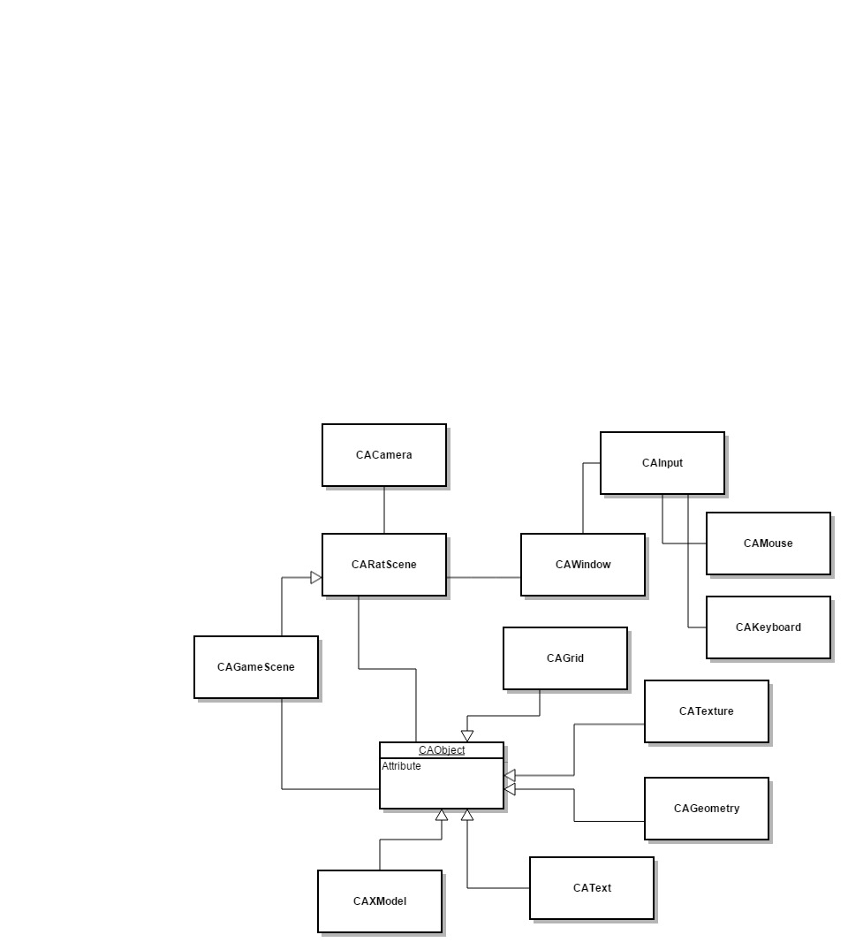

CARootScene

Figure 1 UML Diagram

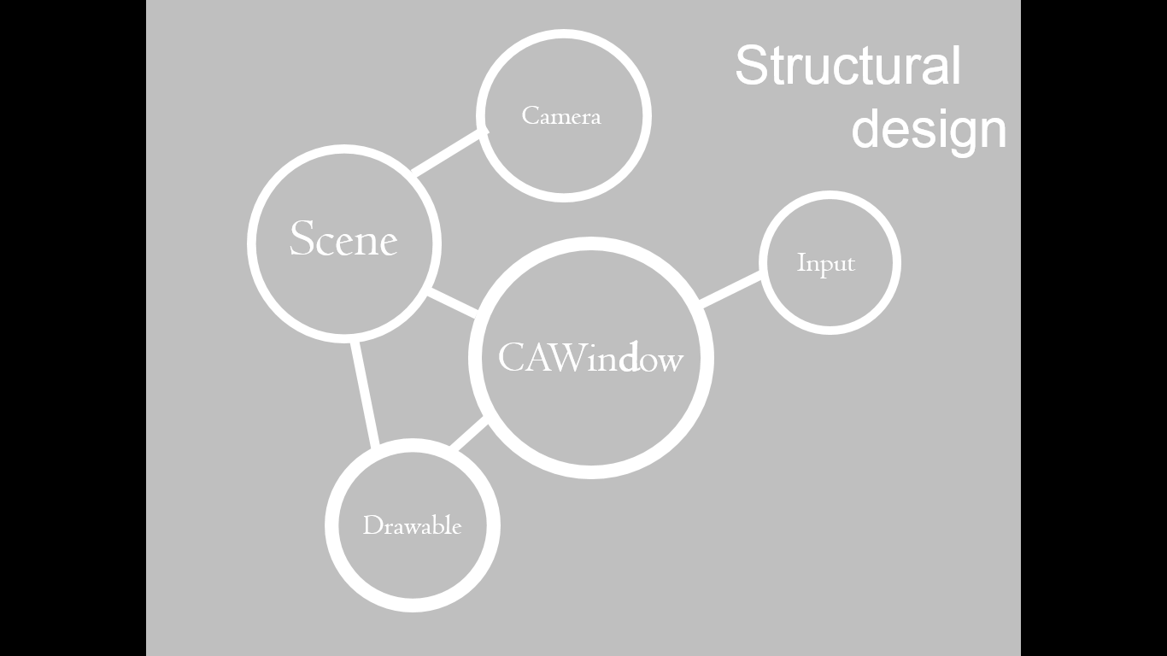 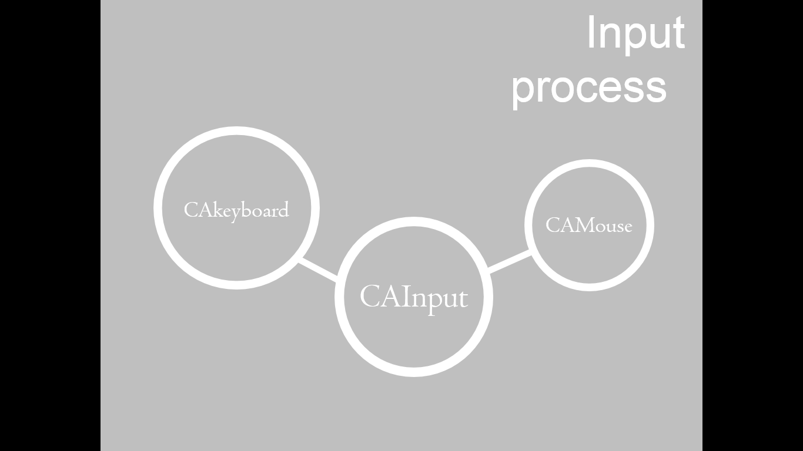

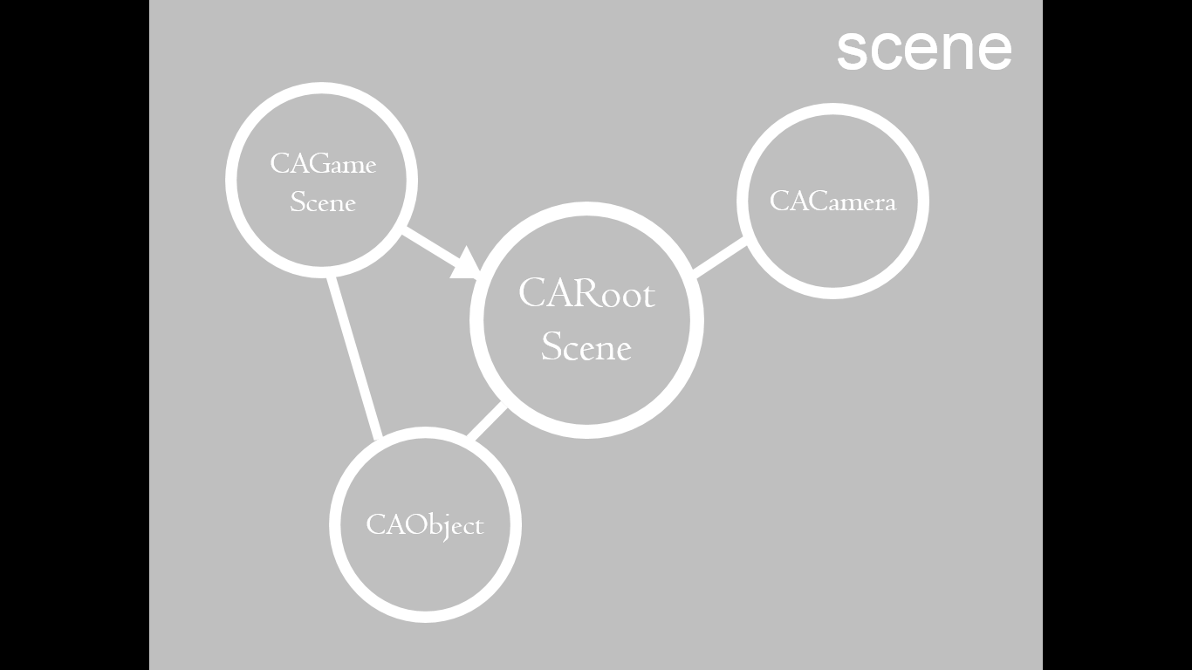 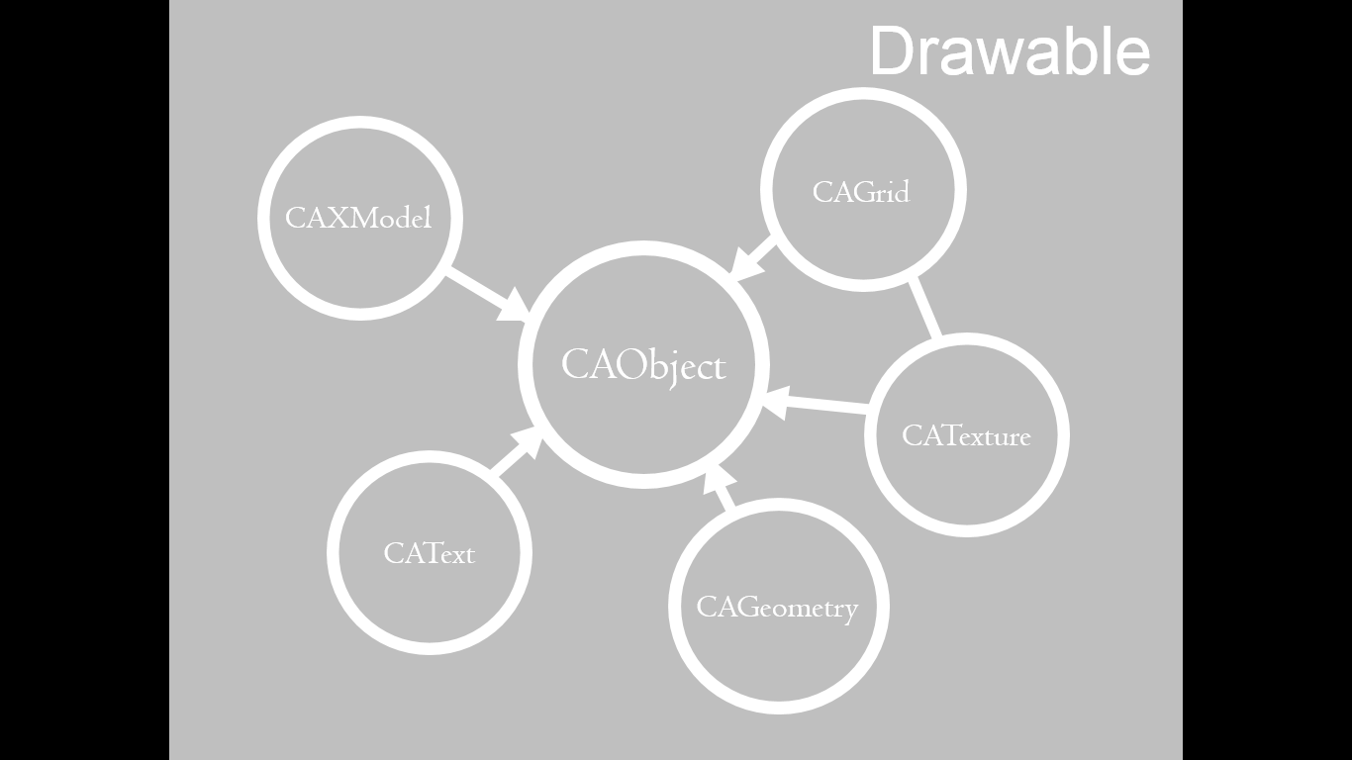

# Execution Results

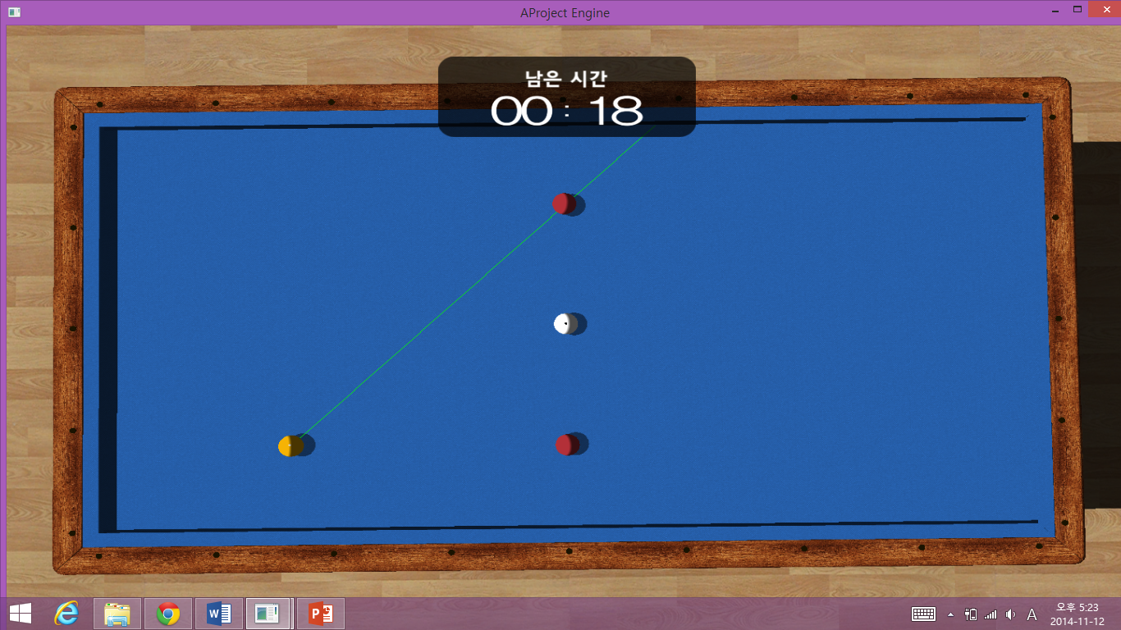

Screen displayed when choosing the direction of the ball

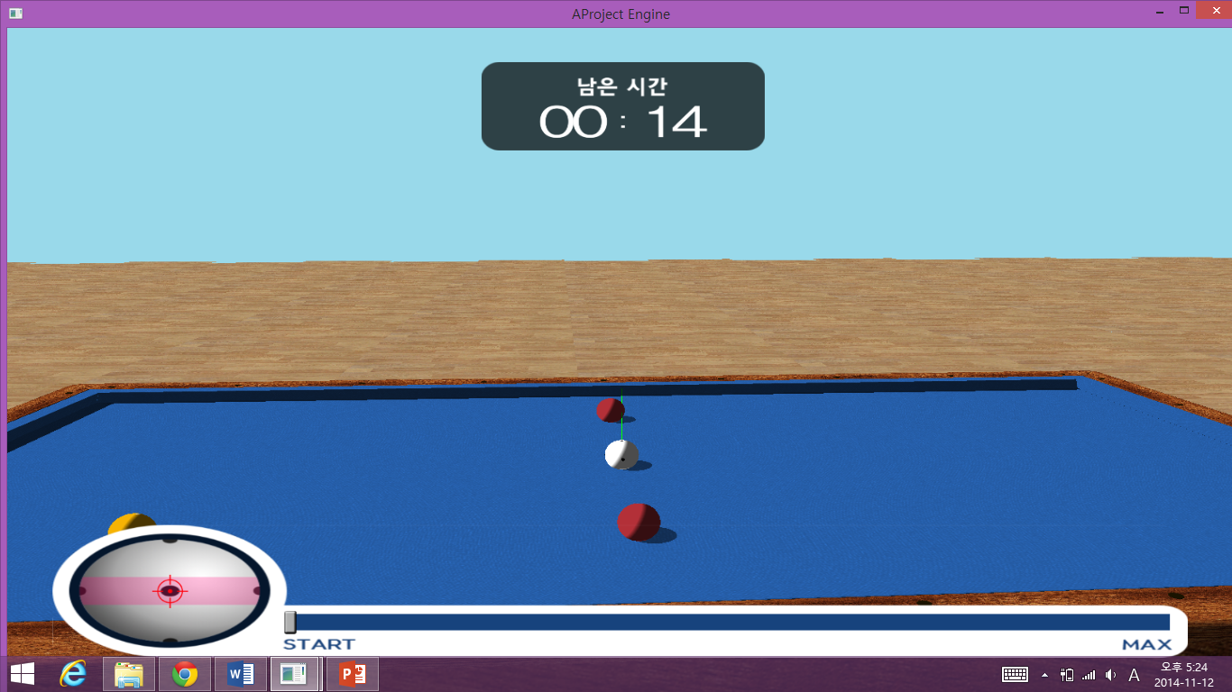

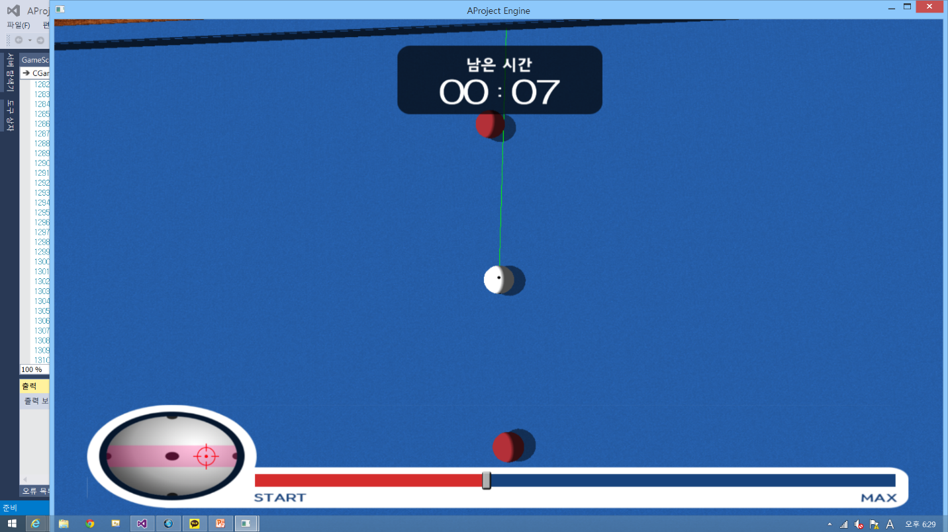

Screen displayed when choosing the hitting place

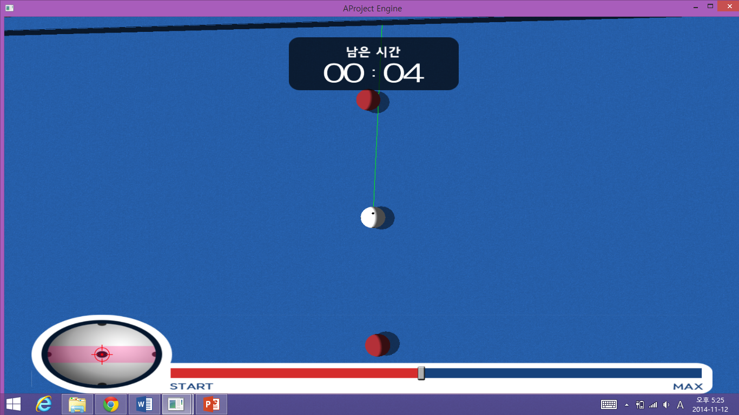

Screen displayed when charging the strength of hit

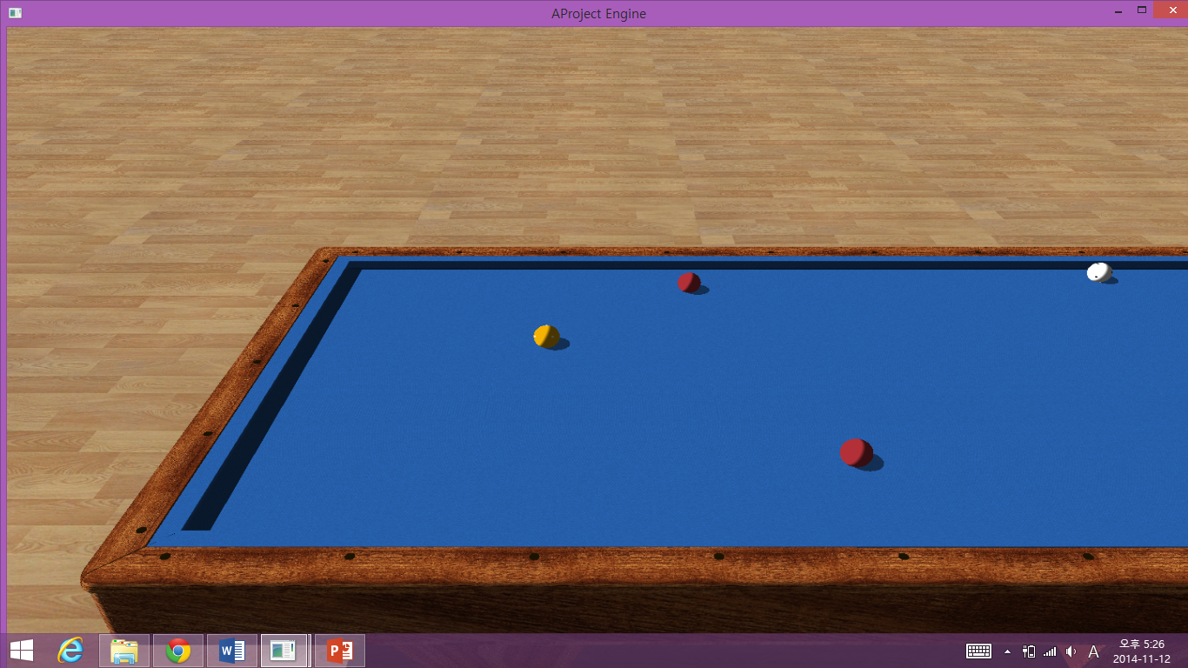

The camera view is continuously changing, following the movement of the ball that is hit. In this case, the camera is following the yellow ball since the yellow ball is the one that is hit.

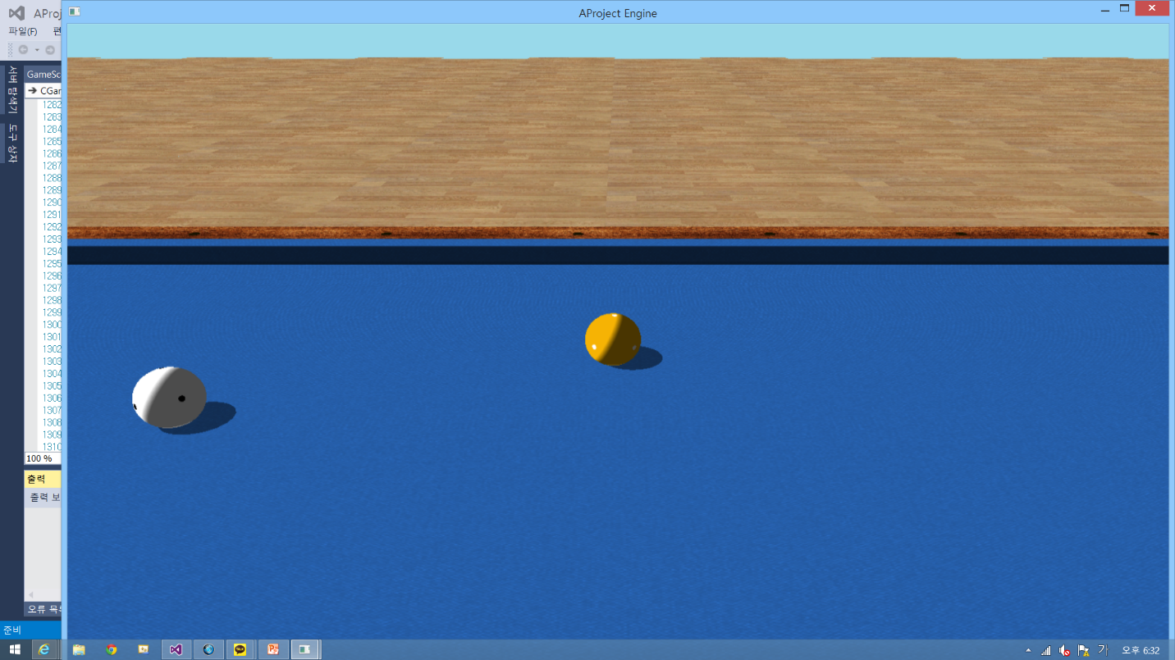

We can see the ball spinning at the end when the ball is hit on the sides.

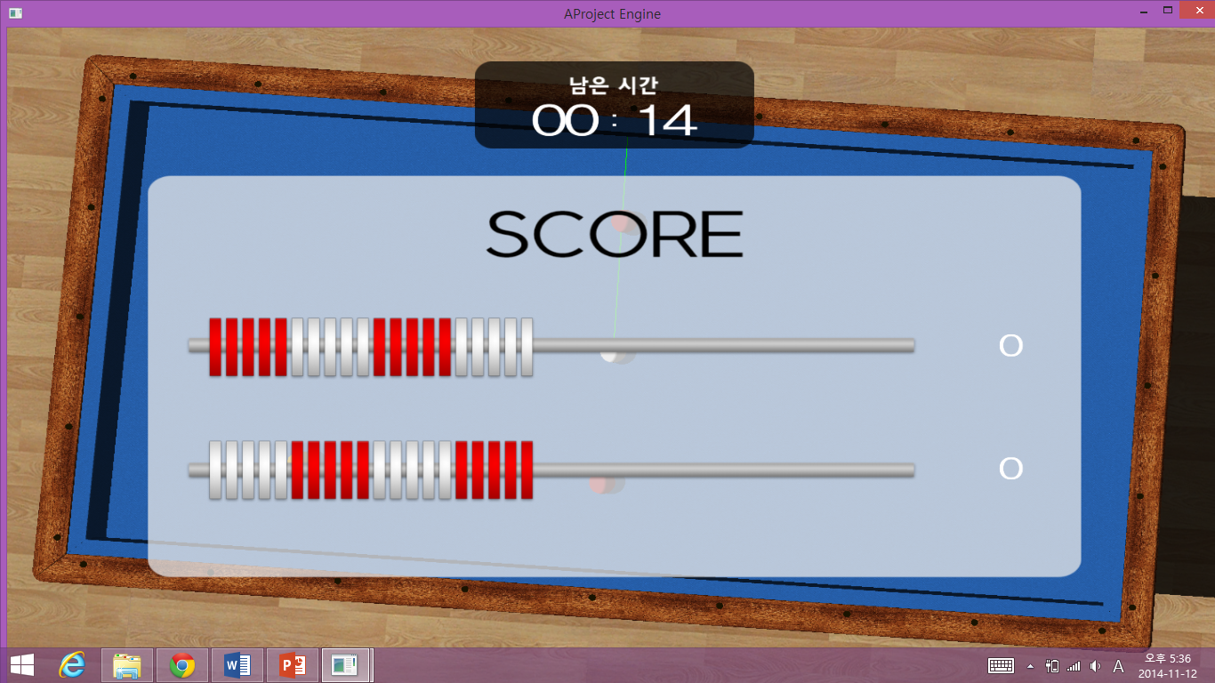

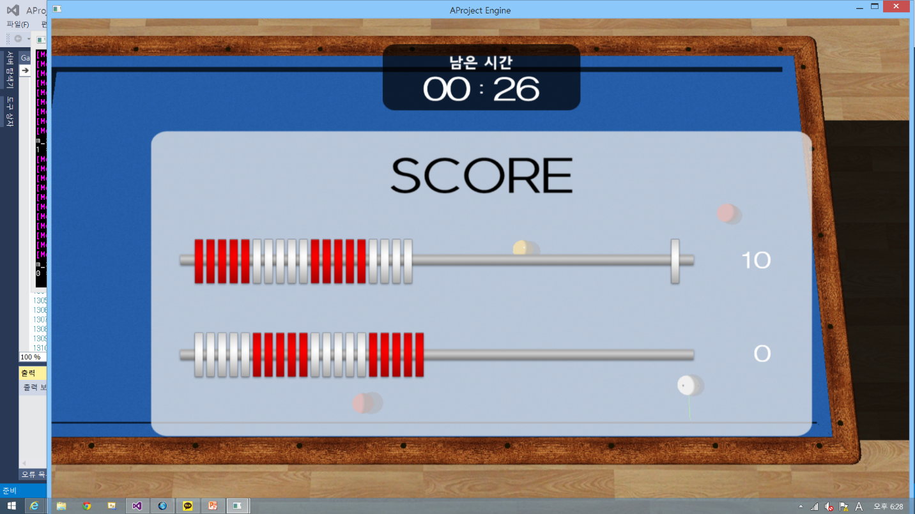

Screen displayed when tab key pressed

# OOP Concepts & What we felt and learned

예를 들어 CAobject 클래스에는 포지션이나 사이즈나 회전, 직교 함수를 하나로 묶어서 create, update, Render, Destroy를 할 수 있도록 만들었다. 그리고 여러 Scene이 필요하므로 생길 때마다 CARootScene을 만들어 상속받을 수 있게 하였다. 여기서도 똑같이 create, update, Render, Destroy를 할 수 있다. 그 외에도 더 많지만 위에서 그림으로 표현을 한 것과 같이 서로 연결된 구조로 되어있으므로 자세한 설명은 생략하겠습니다.

화면에 나타나는 물체는 형태를 가지고 있지만 공간에 존재하지 않아서 겹치기도 한다. 겹치지 않게 하기 위해 공들의 중심 사이의 거리가 지름의 길이랑 같은지 확인을 해야 된다. 이뿐 아니라 그 외에 형체가 없으므로 발생하는 모든 문제에 대해서 한 번 더 생각을 해야 된다는 걸 알았다. 이를 토대로 우리가 하는 일은 형체가 없는 것을 형체가 있게끔 만드는 것이라 생각 들었다.

이번에 처음으로 3차원에 대해 다루게 되었는데 3차원을 화면에 표현하기 위해서는 3차원을 2차원으로 바꿔서 표현을 해야 된다는 것을 알았다. 상당히 복잡하고 어려웠다. 또 물리공식을 이용하여 코드를 짜기보다는 인터넷을 이용하여 물리공식을 코드로 바꿔준 것을 찾아서 많이 사용하였는데, 가져온 코드를 읽어보니 알고 있던 물리공식과 많이 달랐다. 이해를 해보니 이렇게도 표현할 수 있다는 것에 놀랄 뿐이었다.

팀 프로젝트라서 그런지 서로의 코드를 동기화 시키는 작업에 오랜 시간이 걸렸다. 서로의 코드를 이해하고, 변수를 바꾸고, 하나로 만드는 과정이 중요하다는 것을 알았다. 그래서 매일 같이 만나서 작업을 하였다. 가끔씩 다투는 일도 있었지만 그래도 서로에 대해 더 잘 알게 되었다.

# Conclusion